**Front-End Assignment**

**Part-1 Web Designing**

**Module (3) HTML**

1. Are the HTML tags and elements the same thing?

No, HTML tags and elements are not the same thing.

• Tags are part of the HTML markup and are used to create HTML elements. Tags usually come in pairs: an opening tag (e.g., <p>) and a closing tag (e.g., </p>).

• Elements consist of the opening tag, content (if any), and the closing tag. For example, <p>This is a paragraph.</p> is a paragraph element.



2. What are tags and attributes in HTML?

• Tags are used to mark up the start and end of an element in HTML. Tags are enclosed in angle brackets, e.g., <tagname>content</tagname>.

• Attributes provide additional information about an element and are included within the opening tag. They are defined by a name and value pair, e.g., <tagname attribute="value">.

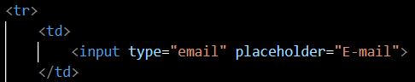

3. What are void elements in HTML?

Void elements (also known as self-closing or empty elements) are HTML elements that do not have any content and do not require a closing tag. Examples include <img>, <br>, <hr>, <input>, and <meta>.

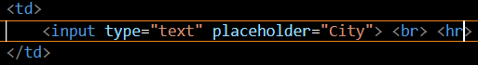

4. What are HTML Entities?

HTML entities are used to represent special characters that cannot be included directly in the HTML code. They are written as &entity_name; or &#entity_number;. For example, &amp; represents &, and &#169; represents the © symbol.

5. What are different types of lists in HTML?

There are three types of lists in HTML:

• Ordered lists (<ol>): A list of items in a specific order, typically numbered.

• Unordered lists (<ul>): A list of items without a specific order, typically bulleted.

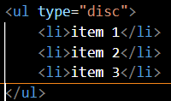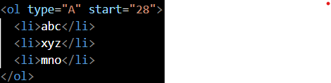• Definition lists (<dl>): A list of terms and their definitions, with <dt> for terms and <dd> for definitions.

8. What are the various formatting tags in HTML?

Formatting tags in HTML are used to apply styles to text. Common formatting tags include:

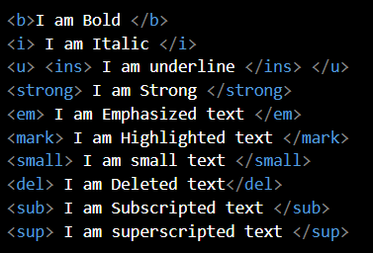• <b>: Bold text

• <i>: Italic text

• <u>: Underlined text

• <strong>: Strongly emphasized text (usually bold)

• <em>: Emphasized text (usually italic)

• <mark>: Highlighted text

• <small>: Smaller text

• <del>: Deleted text (strikethrough)

• <ins>: Inserted text (underline)

• <sub>: Subscript text

• <sup>: Superscript text

9. How is Cell Padding different from Cell Spacing?

• Cell Padding: The space between the cell content and the cell border. It is controlled using the padding attribute in CSS.

• Cell Spacing: The space between individual cells in a table. It is controlled using the border-spacing property in CSS.





10. How can we club two or more rows or columns into a single row or column in an HTML table?

• Rows: Use the rowspan attribute in a <td> or <th> element to span multiple rows.

• Columns: Use the colspan attribute in a <td> or <th> element to span multiple columns.

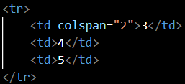Example:

<table>

<tr>

<td rowspan="2">Rowspan 2</td>

<td>Cell 1</td>

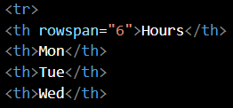 </tr>

<tr>

<td>Cell 2</td>

</tr>

<tr>

<td colspan="2">Colspan 2</td>

</tr>

</table>

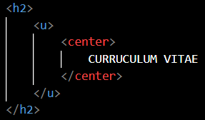11. What is the difference between a block-level element and an inline element?

• Block-level elements: Occupy the entire width of their parent container and start on a new line. Examples include <div>, <p>, <h1>, <ul>, and <li>.

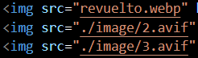• Inline elements: Occupy only the width required by their content and do not start on a new line. Examples include <span>, <a>, <img>, <strong>, and <em>.

12. How to create a Hyperlink in HTML?

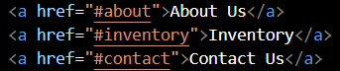To create a hyperlink, use the <a> tag with the href attribute specifying the URL.

Example:

<a href="https://www.example.com">Visit Example</a>

13. What is the use of an iframe tag?

The <iframe> tag is used to embed another HTML document within the current document. It can display web pages, videos, maps, etc.

Example:

<iframe src="https://www.example.com" width="600" height="400"></iframe>

14. What is the use of a span tag? Explain with example?

The <span> tag is an inline container used to group text or elements for styling purposes or to manipulate with JavaScript. It does not inherently represent anything.

Example:

<p>This is a <span class="highlight">highlighted</span> text.</p>

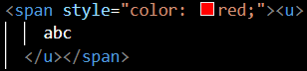<style>

.highlight {

background-color: yellow;

}

</style>

15. How to insert a picture into a background image of a web page?

Use CSS to set a background image for an element (e.g., <body>, <div>).

Example:

<body style="background-image: url('background.jpg');">

 <!-- Content here -->

</body>

16. How are active links different from normal links?

• Normal links: Links that have not been clicked or interacted with.

• Active links: Links that are currently being clicked or interacted with. They are usually styled using the :active pseudo-class in CSS.

Example:

<style>

a:link { color: blue; }

a:visited { color: purple; }

a:hover { color: red; }

a:active { color: orange; }

</style>

17. What are the different tags to separate sections of text?

Different tags used to separate sections of text include:

• <div>: A block-level container for content

• <p>: Paragraph

• <hr>: Horizontal rule (line)

• <br>: Line break

• <section>: A section of content

• <article>: An independent piece of content

• <aside>: Content tangentially related to the main content

• <header>: Header for a document or section

• <footer>: Footer for a document or section

• <nav>: Navigation links

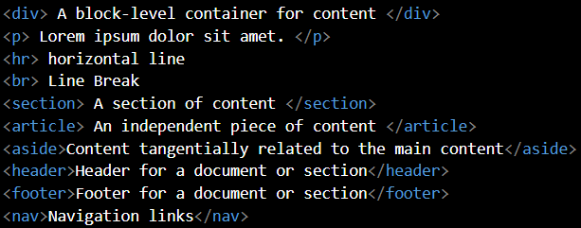

18. What is SVG?

SVG (Scalable Vector Graphics) is an XML-based format for describing vector graphics. It allows for images to be scaled infinitely without loss of quality.

Example:

<svg width="100" height="100">



<circle cx="50" cy="50" r="40" stroke="black" stroke-width="3" fill="red" />

</svg>

19. What is difference between HTML and XHTML?

• HTML (HyperText Markup Language): A markup language for creating web pages. It is more lenient with syntax rules.

• XHTML (Extensible HyperText Markup Language): A stricter version of HTML that follows XML syntax rules. Tags must be properly closed, nested, and in lowercase.

20. What are logical and physical tags in HTML?

• Logical tags: Describe the meaning or structure of the text. Examples include <em>, <strong>, <cite>, and <dfn>.

• Physical tags: Describe the appearance of the text. Examples include <b>, <i>, <u>, and <tt>.

Logical tags are generally preferred as they provide semantic meaning to the content.